**Crestron Certified Integrated Partner Module: Gain Increment Decrement v2.0**

**Models:** Symetrix Integrator Series; 722, 760, 761, 780, 788. Jupiter Series; J4, J8, J12. SymNet; 8x8 DSP, Express Cobra DSP, Solus DSP, Edge DSP, Radius DSP.

**Device Type:** Audio Mixer, DSP.

**General Information**

The Certified Crestron Module SymNet Gain Increment Decrement is used to control any parameter which has a SymNet Controller Number assigned to it. The module increases, or decreases the value of the Controller Number by a specified amount depending on the number of button pushes. It is a step up, or step down gain module which makes use of the CC (Controller Change) command.

**Category:** Mixer, Audio DSP.

**Version:** 2.0

**Summary:**

The SymNet Gain Increment Decrement Crestron module is used to raise and lower therange of any SymNet Controller in steps. It is an alternative to drawing a slideron the touch-panel and implementing the Fader module to accomplish gain adjustments.

**General Notes:**

This module combines Increment and Decrement functionality into one module. Once a SymNet Controller Number is assigned, the value of this controller can be changed by using this module in a Crestron control system. The value of the SymNet Controller is between 0 and 65,535. It is worth noting how many counts of the 65,535 are necessary to achieve the gain adjustment that is desired. The SymNet 3rd Party Control Protocol makes use of a CC (Controller Change) commands. This is different from a CS (Controller Set) command in that it doesn't just tell the Controller Number what value to go to, it tells the Controller Number to increase, or decrease its value from where it is currently by a designated amount. The format of the string is ***CC*** (Controller Change), ***0/1*** (for DEC/INC) ***#*** (Controller Number), ***Value*** (Value between 0-65535). For Example, raising SymNet Controller #1 by 3dB on an 84dB scale would be: ***CC 1 1 2341***. Lowering the same Controller by 1dB on the same scale would look like: ***CC 0 1 781.***

**Crestron Hardware Required:**

2 or 3 Series. RS-232, or UDP card required.

**Setup of Crestron Hardware:**

*RS-232.* Baud Rate; 38400 to 115200 - Configurable through SymNet Software Application. 8 Bit, Non-Parity, Stop Bit; 1, Flow Control; None.

*Crestron Cable Type.* CNSP-121

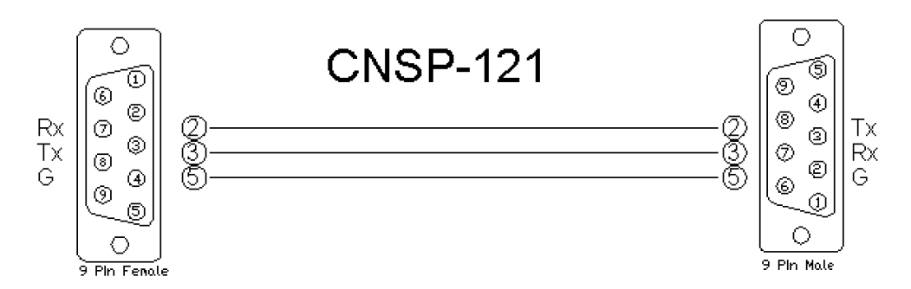

*UDP/IP.* Port: 48630.

**Application Notes:**

Please notice the scale that you are working with once the SymNet Controller Number is assigned. All SymNet Controller Numbers have a potential value of between (0) and (65,535). To allow the user to adjust the gain stage with precise dB increments, be sure to find out how many counts of the 65,535 are equal to (1) deciBel. The majority of SymNet audio faders have a scale of 84dB that they are working with. The following calculation can be used when controlling the typical SymNet gain stage, in orderto find out how many counts are associated with a desired dB amount. 1dB = 65,535 counts/84dB = 781 counts.

**Module Graphic:**

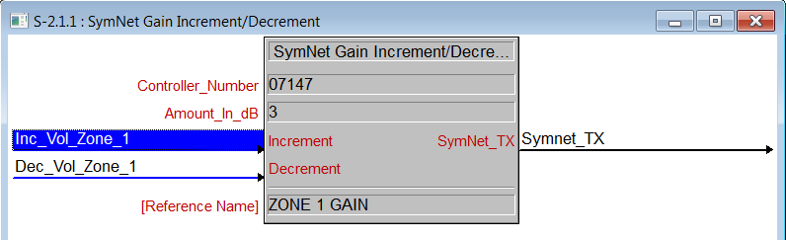

**Control:**

*Increment.* Signal Type: Digital. This is the location where the integrator will place the touch-panel variable associated with the Increase Volume button. *Decrement.* Signal Type: Digital.   This is the location where the integrator will place the touch-panel variable associated with the Decrease Volume button. *SymNet TX.* Signal Type: Serial. This is the transmission from the Crestron module(s) and project of the serial string.

**Parameters:**

*Controller_Number.* Signal Type: Variable to be entered by the integrator. This will be the SymNet Controller Number. *Amount_in_dB.* Signal Type: Variable to be entered by the integrator. This is the amount in dB that the gain stage will move up and down with the module's button presses. It is acceptable to put any number from (1) to (84).

**Feedback:**

*N/A.* There is not any feedback necessarily coming from the SymNet device into this module. If you need to see level, perhaps placing a meter for the gain level would be sufficient. Please see SymNet Controller Receiver. In order to have the buttons actually appear to engage on the touch panel, put the same variable that is the button press into the feedback portion of the touch-panel module in SIMPL. This will give the buttons the appearance of going into their active state for the moment when pressed.

**Testing:**

*SymNet OS.* SymNet Designer v10.06, SymNet Composer v1.1, Jupiter Software v2.0.1.12, Integrator Series 761 Software v2.01. *SIMPL OS.* 4.01 *Crestron DB.* 35.00.004.00